Financial summary
The FRC is a statutory body under the Family Responsibilities Act 2008 and for the purposes of the:
- Financial Accountability Act 2009
- Financial and Performance Management Standard 2019
- Statutory Bodies Financial Arrangements Act 1982.
This summary provides an overview of the FRC’s financial performance for 2020-21 and a comparison to 2019-20. A comprehensive set of 2020-21 financial statements covering all aspects of the Commission’s activities commences on page 72.

Our performance
The operating result for 2020-21 was a surplus of $355K as compared to a surplus in the 2019-20 year of $1.464M.
Table 10: Summary of financial performance.
Summary statement | 30 Jun 2021 | 30 Jun 2020
 | $000 | $000
Income | 4,184 | 4,991
Less: expenses | 3,829 | 3,527
Operating surplus | 355 | 1,464

Income
Table 11: Summary of income by type.
Income by type | 30 Jun 2021 | 30 Jun 2020
 | $000 | $000
State Government funding | 2,359 | 2,262
Australian Government funding | 1,800 | 2,700
Other revenue | 25 | 29
Total | 4,184 | 4,991
The increase in State Government funding is the application of a CPI increase. The decrease in Australian Government funding of $900K is in relation to the receipt of a back payment for the period 1 January 2019 to 30 June 2019, received in December 2019 upon execution of the MoU with the Queensland Government (which expired on 30 June 2021). Other revenue decreased this year and is primarily interest received. The decrease as compared to the prior year is due to a reduction in interest rates resulting in lower interest received.

Expenses
Table 12: Summary of expenses by type.
Expenses by type | 30 Jun 2021 | 30 Jun 2020
 | $000 | $000
Employee expenses | 2,827 | 2,454
Supplies and services | 938 | 1,011
Depreciation and amortisation | 19 | 17
Finance/borrowing costs | 2 | 2
Other expenses | 43 | 43
Total | 3,829 | 3,527

Employee expenses increased in 2020-21 due to staff vacancies being filled and the appointment of a Deputy Commissioner (a role which had been vacant for the full 2019-20 year).
The decrease in supplies and services is due primarily to the engagement in 2019-20 on a contract basis of the former Commissioner for a period of five weeks to undertake training and handover to the new Commissioner, as well as the engagement of a consultant to assist with various operational reviews and governance projects. These costs were not incurred in 2020-21. This decrease was partially offset by an increase in staff travel as COVID-19 restrictions eased and travel to our communities recommenced.
The core functions of the FRC can be summarised into three broad categories:
- Corporate governance: including corporate governance, finance, statistical reporting, training and other administrative functions to ensure the effective and efficient operations of the Commission.
- Community operations: including the operational costs in each of the five communities to conduct conferences and hearings, prepare and monitor case plans for clients for attendance at community support services and prepare and monitor income management orders.
- Conference and hearing facilitation: including to facilitate the holding of conferences and hearings in the five communities, provide support to the Local Commissioners and Local Registry Coordinators to hold conferences and hearings, assist with the on-going monitoring of case plans for clients through the provision of data and other information and process income management orders where considered necessary.
The allocation of the FRC’s costs in 2020-21 based on the above core functions was:
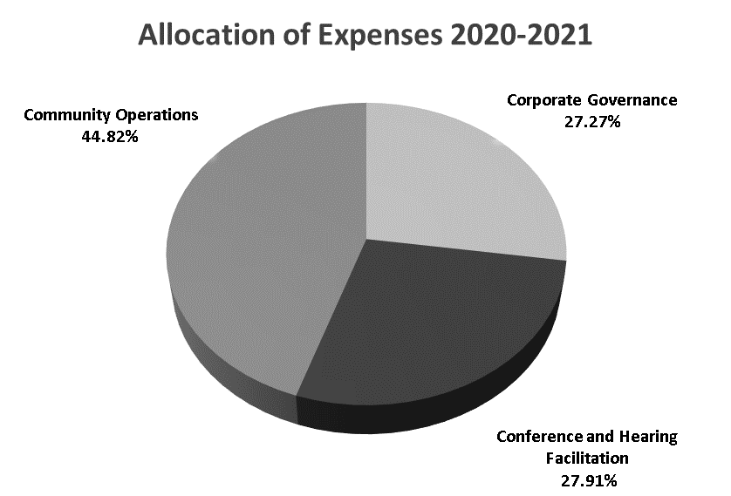
Graph 7: Allocation of expenses
1 July 2020 to 30 June 2021.
The functions of corporate governance and conference and hearing facilitation are conducted primarily in the registry office in Cairns with frequent visits to community by staff. Community operations are conducted by Local Registry Coordinators and Local Commissioners,
resident in their respective communities. The Local Commissioners are paid as sessional sitting Commission members for conferencing, hearings, serving notices, meetings and professional development.
The largest allocation of FRC expenses is in relation to community operations conducted in our five communities broken down as follows:
Table 13: Summary of expense by community.
Community operations expenses by community | 30 Jun 2021
 | $000
Aurukun | 420
Coen | 125
Doomadgee | 733
Hope Vale | 292
Mossman Gorge | 146
Total | 1,716

Our position
Total assets as at 30 June 2021 consisted of current assets of cash, prepayments and receivables in addition to non-current plant and equipment and right-of-use assets.
Total liabilities as at 30 June 2021 consisted of payables, accrued employee benefits and lease liabilities.
Table 14: Statement of financial position.
Statement of financial position | 30 Jun 2021 | 30 Jun 2020
 | $000 | $000
Total assets | 3,640 | 3,205
Total liabilities | 392 | 312
Net assets | 3,248 | 2,893
Total equity | 3,248 | 2,893

